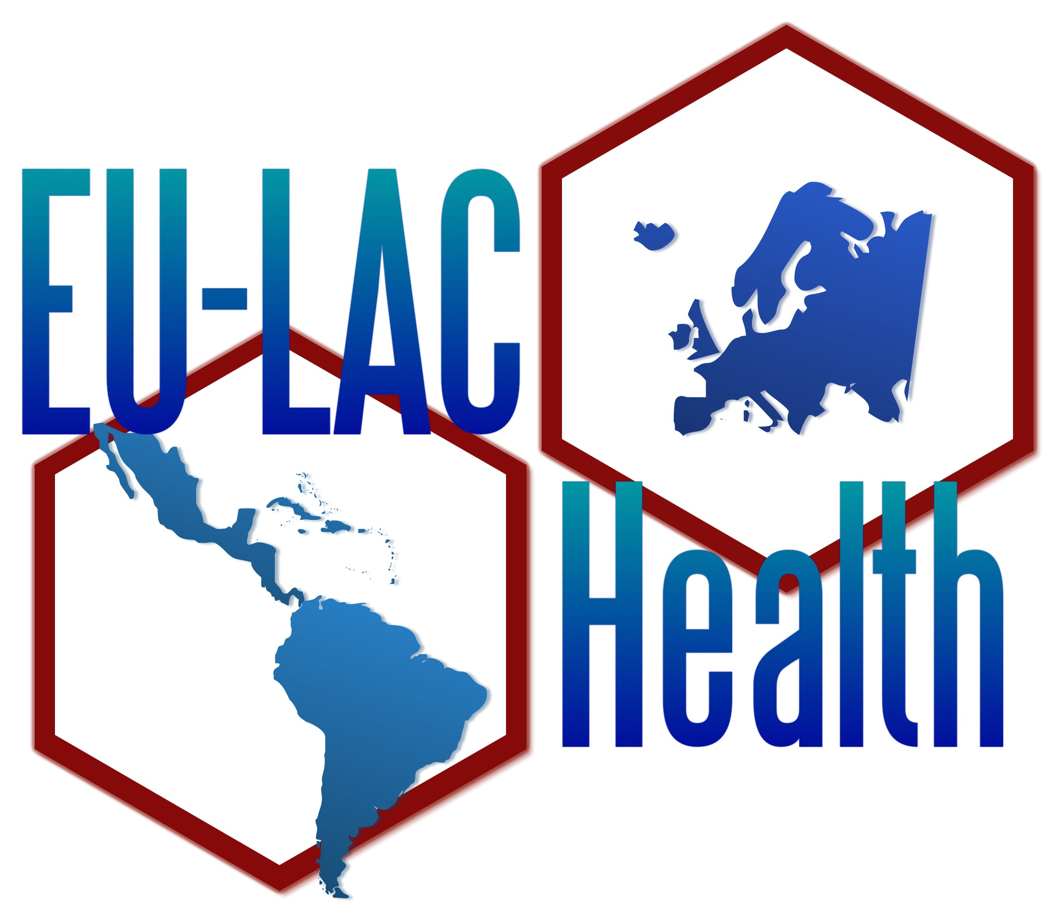
For Immediate Release

EU-LAC Health State of Play Workshop held in Rio de Janeiro…
Rio de Janeiro, Brazil, 19-20 March 2012
On March 19th and 20th 2012, the first EU-LAC Health expert-workshop, organized by Fundação Oswaldo Cruz (FIOCRUZ), took place in Rio de Janeiro. EU-LAC Health is a 5-year project co-financed by the European Commission through the 7th Framework Program (Health theme). Its aim is to discuss commonly with scientists, policy-makers and stakeholders an efficient coordination of health research policies and funding between the EU and LAC as well as to establish a consensus roadmap for cooperative health research for the future common collaboration.
Altogether, the eight project partners, along with invited high-level Advisory Board-Members as well as several external experts from the European Union (EU) and from Latin America and the Caribbean (LAC) countries, discussed the current state of the EU-LAC Health research collaboration and planned future activities.
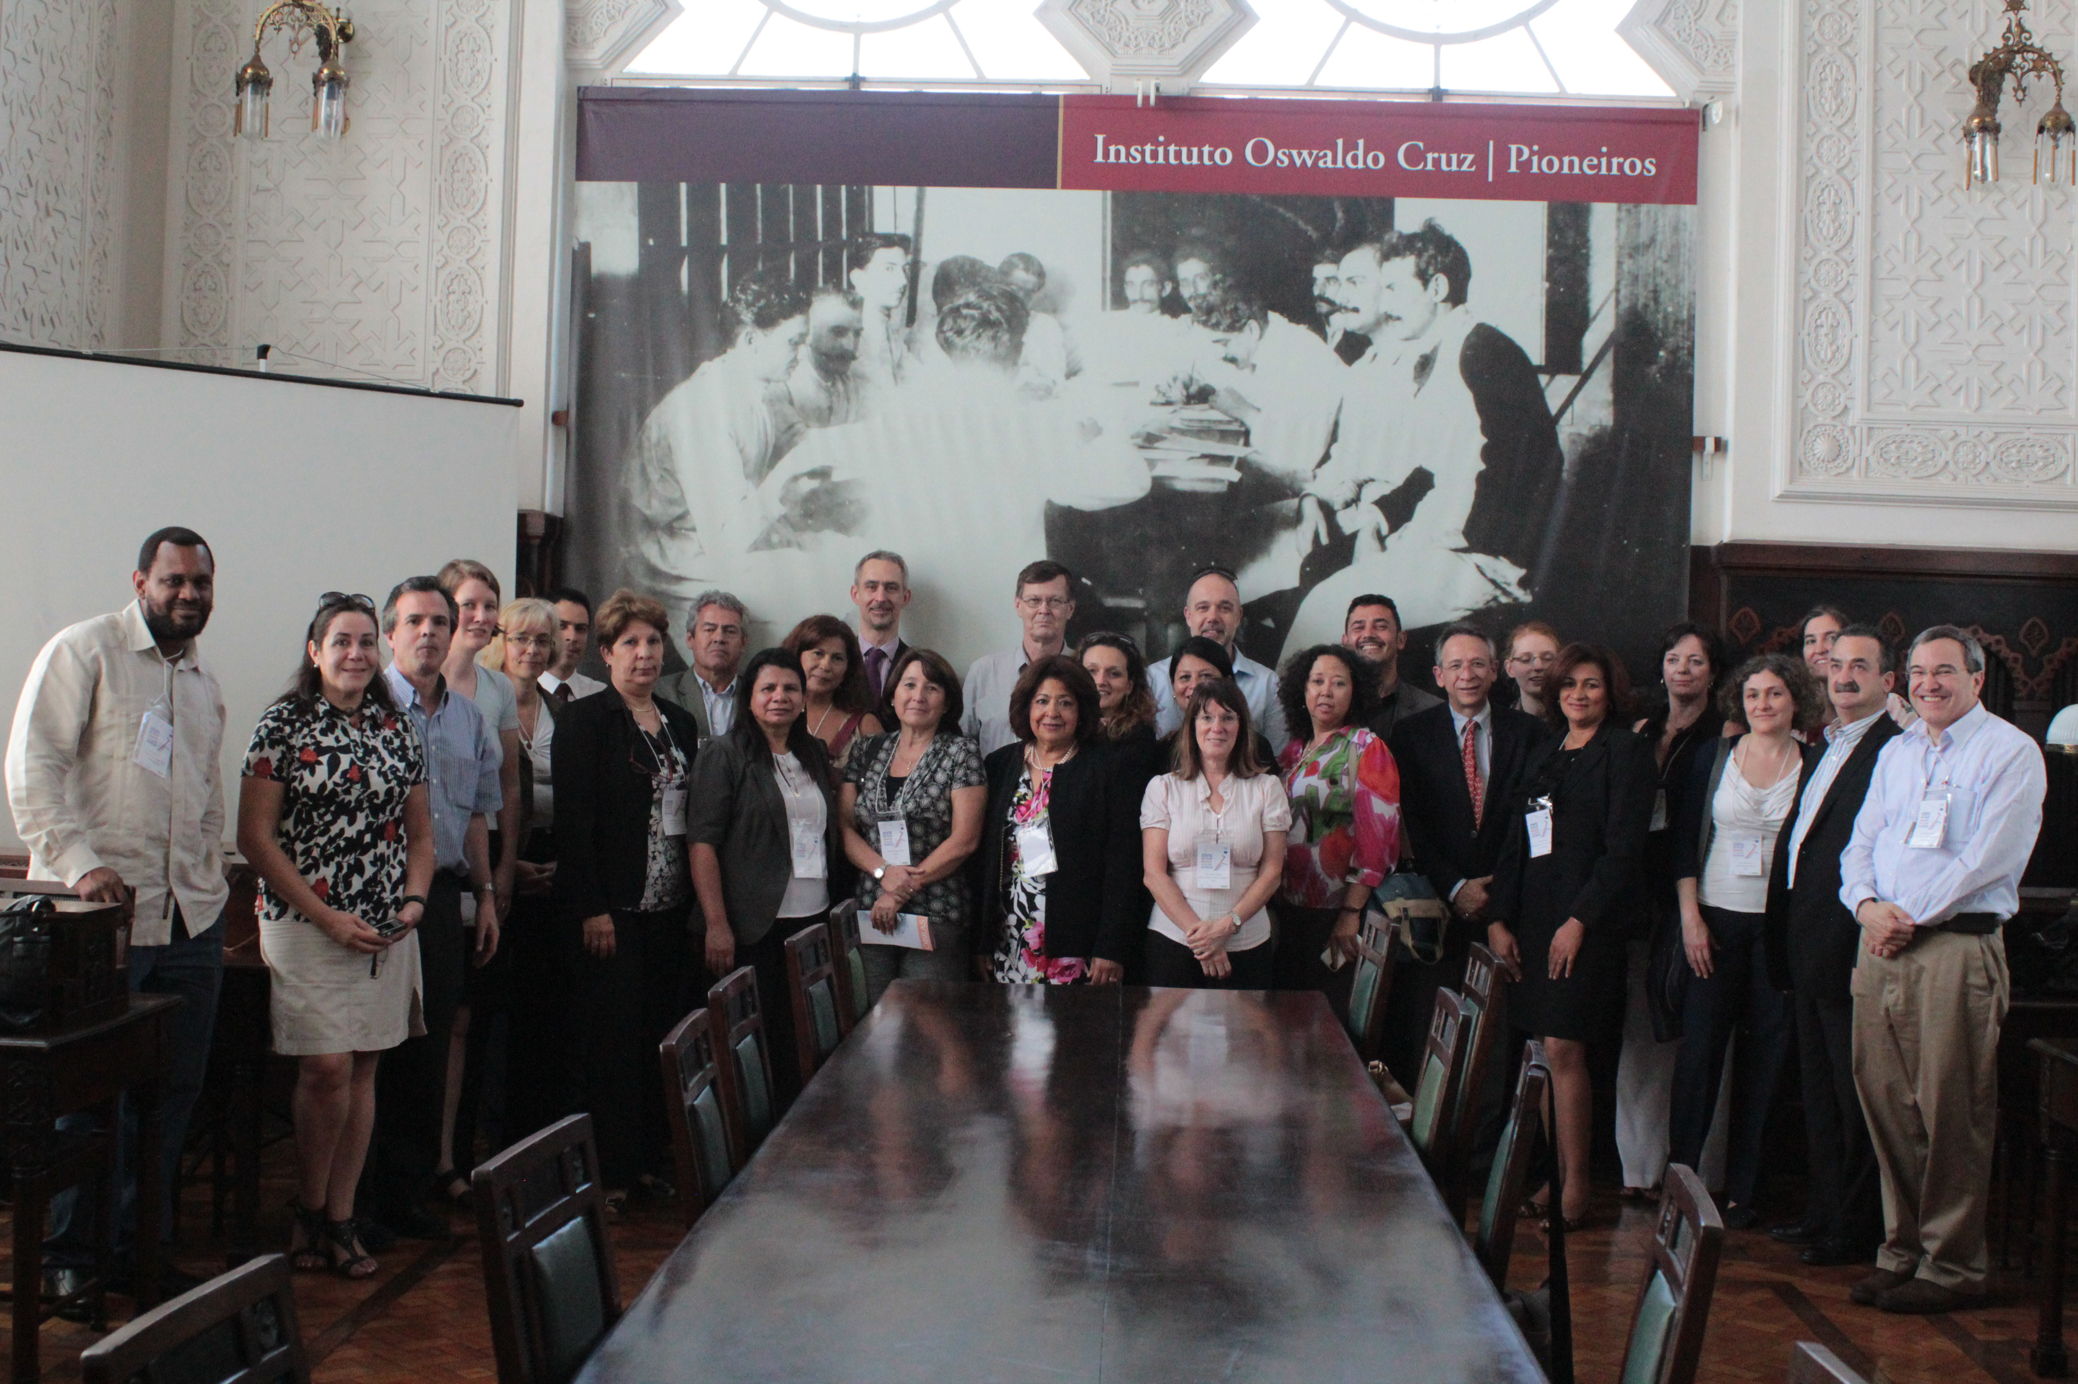
In the workshop the project partners presented an analysis of the present situation of the R&D on health in the LAC and the EU, the identification of research for health funding programs and the existing legal framework of Science & Technology collaboration between LAC and EU. It was generally acknowledged that both regions have a strong scientific potential but that the differences between and within the two regions have to be kept in mind when collaboration is envisaged.
The vivid discussions were enriched by short presentations of some of the invited external experts sharing their experiences in relation to research collaboration, capacity building and mobility. High-level representatives from Argentina, Chile, the Dominican Republic or Trinidad and Tobago, amongst others, contributed with their experiences. Several short presentations concerning different networks, like the Network for Research and Training in Tropical Diseases in Central America (NeTropica) or RIMAIS, the Ibero-American Network of Learning and Research in Health, depicted good practices and experiences. Such mechanisms could be taken as an example for good international collaboration and might help to distribute the idea and outcome of the EU-LAC Health-project, as was stated in the lively discussion after the presentations. Both, project partners and all invited experts showed enthusiasm and elation regarding the future project development.
The next workshop that will be organized by the Ministry of Science and Technology from Argentina, (MINCyT), will take place at the end of October 2012 in Buenos Aires, and will deal with the major challenges in the future of EU-LAC collaboration in Health Research. This as well as the following workshop organized by the Agency for the Promotion of European Research (APRE) in Rome, will use scenario building techniques in order to develop a first draft of the envisaged roadmap.
Project-Homepage with a description, information material, flyers and a complete list of the project partners under: www.eulachealth.eu
Project-partners: ISCIII (Spain), INNOVATEC (Spain), APRE (Italy), COHRED (Switzerland/Mexico), DLR (Germany), MINCyT (Argentina), FIOCRUZ (Brazil), RIMAIS (Costa Rica).
If you’d like more information about this topic, or schedule an interview, please call at +34 -918 222 272 or email at eulachealth@isciii.es.

